Seaside Aquarium

Week 1 - Feeding the Animals

# **Introduction:**

Welcome to your first job at Seaside Aquarium! Today you’ll be in charge of accounting and purchasing food for our marine animals.

At our aquarium we have a range of rescued marine animals such as dolphins, sharks, aquatic fishes, stingrays and penguins. Each of our animals have different dietary requirements and eat a certain species of fish for food.

It is your duty to calculate our spending fees and to inform us how much it will cost to keep our marine animals well fed and healthy. We need your help to determine the costs of food for each animal and how much we will spend in certain time periods.

Your ultimate goal is to get through the day without Seaside Aquarium loosing too much money on food spending or we’ll go broke!

This week’s challenge has two tasks that you ***must complete*** (Task A and B) and bonus tasks (Task C and D).

*You may wish to use* ***Microsoft Excel*** *to help you with these tasks.*

We have placed our trust in you, and good luck!

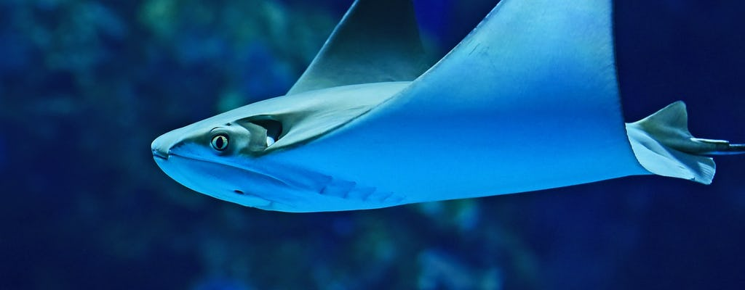

# **Feeding the Animals:**

The following table shows the cost of food per kilogram for each animal and how much they eat per day.

|  |  |  |  |
| --- | --- | --- | --- |
| **Cost for a day of feeding** | | | |
| **Animal** | **Type of food** | **Amount of food** | **Cost of food per kilogram** |
| Dolphin | Salmon | 11.1 kilograms | $4.20 for 1 kilogram |
| Shark | Tuna | 10.8 kilograms | $5.30 for 1 kilogram |
| Aquatic Fish | Fish Food | 7.6 kilograms | $2.40 for 1 kilogram |
| Stingray | Shrimp | 4.4 kilograms | $4.60 for 1 kilogram |
| Penguin | Silverfish | 4.7 kilograms | $3.60 for 1 kilogram |

***TIP:*** *Use Microsoft Excel to make the job easier*

**Task A:**

1. How much would it cost to feed each animal for a day?

What is the total daily cost?

|  |  |
| --- | --- |
|  | Cost ($) of food for 1 day |
| Dolphin |  |
| Shark |  |
| Aquatic Fish |  |
| Stingray |  |
| Penguin |  |
| **TOTAL feeding cost for all animals** |  |

1. How much would it cost to feed each animal for a week?

What is the total weekly cost?

|  |  |
| --- | --- |
|  | Cost ($) of food for 1 week |
| Dolphin |  |
| Shark |  |
| Aquatic Fish |  |
| Stingray |  |
| Penguin |  |
| **TOTAL feeding cost for all animals** |  |

**Task B:**

1. The Seaside Aquarium has rescued more marine animals!

How much would it cost to feed each animal for a week if there are now 2 dolphins,

1 shark, 3 aquatic fishes, 4 stingrays and 8 penguins?

|  |  |  |
| --- | --- | --- |
|  | Total amount of  food (kg) needed | Cost ($) of food for 1 day |
| 2 Dolphins |  |  |
| 1 Shark |  |  |
| 3 Aquatic Fishes |  |  |
| 4 Stingrays |  |  |
| 8 Penguins |  |  |
| **TOTAL feeding cost for all animals** | |  |

1. How much would it cost to feed each animal for the month of February?

What is the total cost of February? (***HINT:*** *February has 28 days*)

|  |  |  |
| --- | --- | --- |
|  | Cost ($) of food for 1 day | Cost ($) of food for February |
| 2 Dolphins |  |  |
| 1 Shark |  |  |
| 3 Aquatic Fishes |  |  |
| 4 Stingrays |  |  |
| 8 Penguins |  |  |
| **TOTAL feeding cost**  **for all animals** |  |  |

**Bonus Task C:**

Seaside Aquarium’s head dietician reads that sharks and stingrays could also eat salmon. Given the increase in quantity required, Seaside Aquarium have negotiated a discount of 22% with the supplier of salmon.

Calculate the new costs to feed all of the animals from Task B, if dolphins, sharks and stingrays eat salmon, and it is 22% discounted. Note: same quantities per animal required.

1. Cost for a Day?

|  |  |  |  |
| --- | --- | --- | --- |
|  | Total amount of  food (kg) needed | Cost of food per kilogram | Cost ($) of food for 1 day |
| 2 Dolphins |  |  |  |
| 1 Shark |  |  |  |
| 3 Aquatic Fishes |  |  |  |
| 4 Stingrays |  |  |  |
| 8 Penguins |  |  |  |
| **TOTAL feeding cost for all animals** | |  |  |

1. Cost for a Week?

|  |  |  |
| --- | --- | --- |
|  | Cost ($) of food for 1 day | Cost ($) of food for a week |
| 2 Dolphins |  |  |
| 1 Shark |  |  |
| 3 Aquatic Fishes |  |  |
| 4 Stingrays |  |  |
| 8 Penguins |  |  |
| **TOTAL feeding cost**  **for all animals** |  |  |

# **Bonus Task D:**

Oh no! We are about to become bankrupt! We need to cut our total costs down per day. Let’s try reducing the quantities of food by 25%. Note: Dolphins, sharks and stingrays are loving their salmon.

***HINT:*** *Original amount of food can be found in the ‘Cost for a day of feeding’ table*

|  |  |  |
| --- | --- | --- |
|  | 3/4 of original  amount of food (kg) | New cost ($) of food for 1 day |
| 2 Dolphins |  |  |
| 1 Shark |  |  |
| 3 Aquatic Fishes |  |  |
| 4 Stingray |  |  |
| 8 Penguins |  |  |
| **NEW TOTAL feeding cost for all animals** | |  |

1. How much will we save with the new total feeding cost for all animals compared to the original cost?

***HINT:*** *Refer back to Task C*

**Submission Link:** [**https://survey.sparkchart.com/start/8PYAMfbGG2XFjNxM6HlU9iEXmTstosbyccSaJVuOs/**](https://survey.sparkchart.com/start/8PYAMfbGG2XFjNxM6HlU9iEXmTstosbyccSaJVuOs/)